TRANSFER STUDENT PLAN OF STUDY

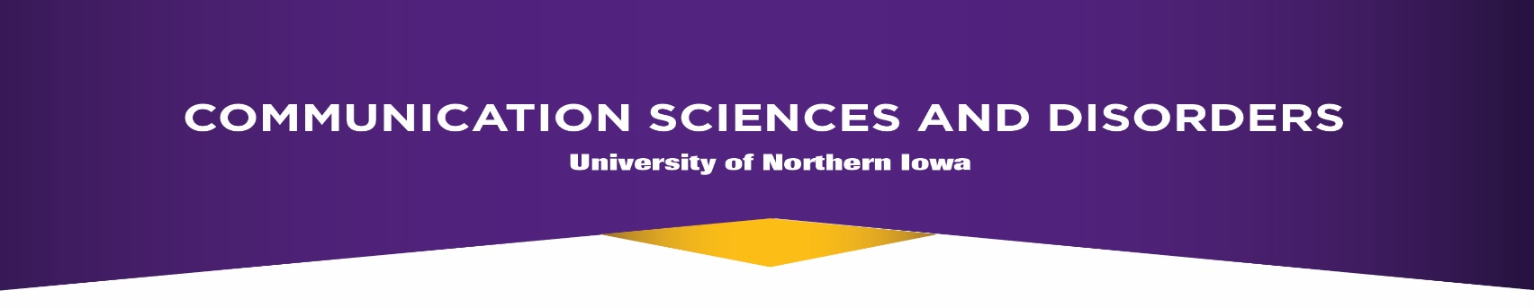
CSD courses must to be taken in sequence.

Junior FALL:_______ | Junior SPRING: ______ | Junior SUMMER:______
1000 Understanding Com Dis 3 | 3100 Lang Acq.: Birth to 5 yrs 3 | xxxx Course Title 0
3260 Hearing Science 3 | 3120 Phonetics 3 | xxxx Course Title 0
Statistics (STAT 1772) 3 | 3135 Anat. & Phys. Of Sp. Mech. 3 | xxxx Course Title 0
xxxx Course Title 0 | 3270 Intro to Audiology 3
xxxx Course Title 0 | xxxx Course Title 0
Semester Total 9 | Semester Total 12 | Semester Total 0
To Date Total 9 | To Date Total 21 | To Date Total 21
 | MUST HAVE A 3.0 GPA TO CONTINUE IN CSD CLASSES AT THIS LEVEL .
Senior FALL:_______ | Senior SPRING: ______ | Senior SUMMER:______
3130 Neuro & Study of Com. 3 | 3140 Intro to Neurogenic Dis 3 | xxxx Course Title 0
3200 Lang. of School-Aged Child. 3 | 3250 Speech Science 3 | xxxx Course Title 0
3220 Disorders of Sp. Sounds 3 | 3700 Com Dis & Diff Across LifSpn* 3 | xxxx Course Title 0
3650 Clinical Processes 2 | 4150 Developmental Neuro.* 3
3900 Aural Rehabilitation 3 | 4500 Clinical Practice 1
Semester Total 14 | Semester Total 13 | Semester Total 0
To Date Total 35 | To Date Total 48 | To Date Total 48
Program recommends students take a course in either Chemistry or Physics to fulfill part of your liberal arts core as
well as courses in biology and social sciences.
*Pre-audiology students should consult with advisor for other recommended courses.
Xxxx Course Title- fill additional credits with Liberal Arts Core, Electives, or an Education Endorsement.

Possible CSD electives: CSD 4100 Augmentative Communication (3 units)
CSD 4210 Current Problems: Counseling for SLPs (2 units)
CSD 3190 American Sign Language I (3 units)
CSD 3195 American Sign Language II (3 units)
CSD 3196 American Sign Language III (3 units)

Revised 7/2019

