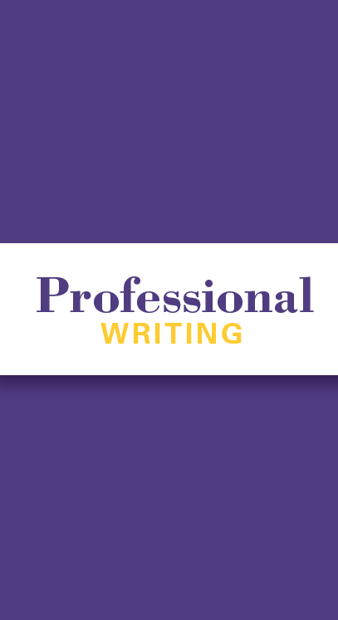  1001 Bartlett Hall  Cedar Falls, IA  50614-0502  t:319.273.2821  https://langlit.uni.edu/  langlit@uni.edu | Professional Writing at UNI  UNI’s Department of Languages and Literatures offers a Writing Minor with a Professional Writing option. This option enables students to experience how their writing, reading and analytical abilities are relevant to creating workplace communications.  Junior and senior-level courses focus on applied writing, meaning that students collaborate with individual and organizational clients throughout the Cedar Valley. These collaborations also generate professional networking opportunities; often clients are UNI alumni.  Since 2005, students in Professional Writing courses have partnered with over 200 clients.  Past students who have taken individual courses or minored in Professional Writing have majored in fields such as English, Communication Studies, Interactive Digital Studies, Marketing, Biology, Math, Anthropology, and Education. | Examples of Past Clients  Beyond Pink Team  Blank Park Zoo  Cedar Falls Community Main Street Cedar Valley Arboretum & Botanic Gardens CEEE FREE  College of Education  College Square Mall  Culture & Intensive English Program Hartman Reserve Nature Center Inclusion Connection  Memories Maid  Office of International Admissions  Race Across America  Senior Corps RSVP  UNI ROTC  Waterloo Community School District Women’s and Gender Studies Program  